Cataloging E-Books
7/12/07 rev. cpk

Fixed Fields

- Workform: Books

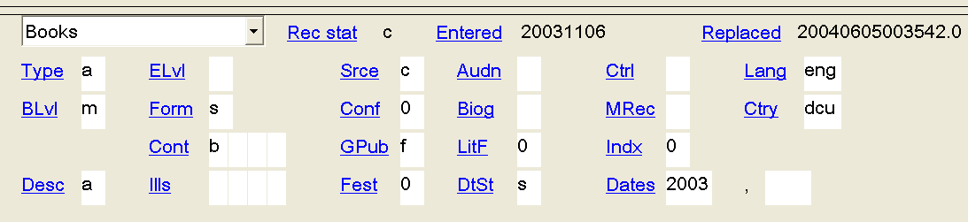
Form: s

- 006

006 |  |  | m d

You’ll typically input:

Type: m | for Computer File  (See OCLC Bibliographic Formats and Standards for more options: http://www.oclc.org/bibformats/en/fixedfield/type.shtm)
File: d | for Document  (See OCLC Bibliographic Formats and Standards for more options: http://www.oclc.org/bibformats/en/fixedfield/file.shtm)

If the resource is a government publication, fill in the GPub field with the appropriate value. For example:
006 |  |  | m d f

To insert the 006 field:
- Enter a blank field the same as you would any other field. (i.e. position the cursor in the field that will precede the 006 field, press “Enter,” and type “006.”)
040 |  |  | CLU ǂb ǂc CLU
006

- Type in the first value (usually “m”).
006 |  |  | m

- Right click and choose the “Edit with Guided Entry…” option.
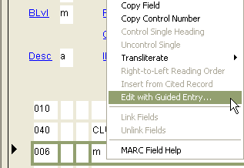

- In the dialog box that appears, fill in the remaining values (eg. “d” for document).
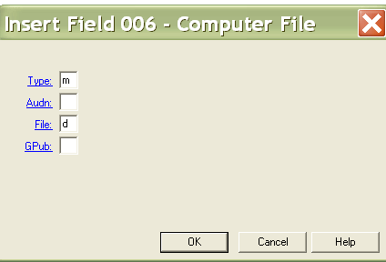

To edit the 006 field:
- Right click and choose the “Edit with Guided Entry…” option.

- In the dialog box that appears, edit the values as appropriate.

Variable Fields

- 007

007 |  |  | c ǂb r ǂd m ǂe n

‡a | Category of material | Mandatory/Mandatory | c : Electronic resource
‡b | Specific material designation | Mandatory/Mandatory | r : Remote
‡d | Color | Mandatory/Mandatory | b : Black-and-white  c : Multicolored  g : Gray scale  m : Mixed
‡e | Dimensions | Required if applicable/ Required if applicable | n : Not applicable
‡f | Sound | Required if applicable/Required if applicable | a : Sound  n : Not applicable

For more options, see OCLC Bibliographic Formats and Standards: http://www.oclc.org/bibformats/en/0xx/007comp.shtm

- 050

050 |  | 4 | HG3881.5.W57
Enter the class number only. Omit the cutter and date.
- 049

049 |  |  | CLYY
The location code in the 049 is always CLYY, regardless of the subject matter or the branch requesting the resource.

In the rare case when an order record in Voyager needs to be overlaid, make sure the holdings record looks like this:
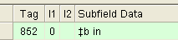
If not, edit the 852 field in the Voyager holdings record. Alternatively, transcribe the 049 in the OCLC record with the appropriate overlay coding.
(For instructions on overlaying records, see the departmental website at: http://www.library.ucla.edu/cataloging/procedures/049InputStandardsSynopsis06Feb.pdf)

- 245 ǂh

245 | 0 | 0 | Dermatology ǂh [electronic resource] : ǂb the profession, the philosophy, the way of life / ǂc edited by W. Sterry.
Always add a subfield h in the 245 with “electronic resource” in brackets.

- 260 ǂc

260 |  |  | Stuttgart ; ǂa New York : ǂb Thieme, ǂc c2006.
For e-books, add the date in the 260 ǂc. (For IR’s the ǂc is usually omitted.)

- 300 (Optional)

300 |  |  | xx, 192 p. : ǂb digital, PDF file
The 300 field is OPTIONAL. If you want to add a 300 field, do so only for e-books. NEVER ADD THE 300 FOR HTML DOCUMENTS!

- 538

538 |  |  | Mode of access: World Wide Web.
Always add a 538 field to denote the mode of access.
(Always “World Wide Web.”)

If cataloging a PDF, a second 538 can be added to describe the system requirements. This 538 would precede the one describing the mode of access, as follows:
538 |  |  | System requirements: Adobe Reader.
538 |  |  | Mode of access: World Wide Web.

- 500

500 |  |  | Title from PDF title page (viewed on Oct. 16, 2003).
500 |  |  | Title from table of contents page (viewed on Apr. 1, 2005).
500 |  |  | Title from PDF caption (viewed on Aug. 22, 2004).
500 |  |  | Title from home page (viewed on Feb. 5, 2007).
Always add a source of title note with the date on which the resource was viewed.
For more examples of source of title notes, see the OLAC guidelines at:
http://ublib.buffalo.edu/libraries/units/cts/olac/capc/stnir.html

- 530

530 |  |  | Also available in print.
If a print version of the resource exists, add this information in a 530 note.

- 520 (Optional for e-books)

520 |  |  | Provides fast, easy information-finding on a variety of general topics listed alphabetically. Gives suggestions for evaluating web sites and the information they contain and uses this criteria for inclusion of the sites selected. A sampling of topics includes acronyms, dictionaries, exchange rates, polls, resume writing, tax information, zip codes. Designed for University of Colorado, Boulder, librarians and clientele, but wide application for identification of useful electronic sites.
A 520 note may be added to summarize the resource. The 520 field is optional for e-books, but required for IR’s.
For information on coding the 520 field, see OCLC Bibliographic Formats and Standards at: (http://www.oclc.org/bibformats/en/5xx/520.shtm).
For more examples of summary notes, see the OLAC guidelines at:
http://ublib.buffalo.edu/libraries/units/cts/olac/capc/summnotes.html

- 506

506 |  |  | Access restricted to subscribers.
Add a 506 note, if there are any access restrictions. (Typically for licensed resources.)

- 856

856 | 4 | 0 | ǂu http://www.richmondfed.org/publications/economic_research  /working_papers/years.cfm/2006/
See Claudia’s document “URLs in Monographic Records” for detailed instructions on coding the 856 field.

- Prototypical record

006 |  |  | m d
007 |  |  | c ǂb r ǂd m ǂe n
042 |  |  | pcc
050 |  | 4 | HG3881.5.W57
049 |  |  | CLYY
245 | 0 | 0 | Dermatology ǂh [electronic resource] : ǂb the profession… / ǂc edited by …
260 |  |  | Stuttgart ; ǂa New York : ǂb Thieme, ǂc c2006.
300 |  |  | xx, 192 p. : ǂb digital, PDF file
538 |  |  | System requirements: Adobe Reader.
538 |  |  | Mode of access: World Wide Web.
500 |  |  | Title from PDF title page (viewed on Oct. 16, 2003).
530 |  |  | Also available in print.
520 |  |  | Provides fast, easy information-finding on a variety of general topics listed alphabetically….
506 |  |  | Access restricted to subscribers.
856 | 4 | 0 | ǂu http://www.richmondfed.org/publications/economic_research  /working_papers/years.cfm/2006/

